ECFO New Candidate Spring Class Rule Guide 2025, Rule 9
Adapted By- Michael Bilica

This is an introductory rulebook. Please use this rulebook as a guide to the official rule book. Consider it an easier to read translation. It is based on my attempt to rewrite the rulebook in my own words so that I can better remember it (This is a good practice by the way). However, if there are any differences between this guide and the rule book, the rule book will be the ultimate authority.

Table of Contents
Rule 9 Conduct of Players and Others 1
Section 1 Helping the Runner 1
Section 2 Illegal Use of Hands and Holding 2
Section 3 Illegal Blocking 3
Section 4 Illegal Personal Contact 5
Section 5 Noncontact Unsportsmanlike Conduct by Players 8
Section 6 Illegal Participation 9
Section 7 Illegal Kicking and Batting 10
Section 8 Noncontact Unsportsmanlike Fouls by Nonplayers 10
Section 9 Unfair Acts 11

Rule 9 Conduct of Players and Others

Section 1 Helping the Runner

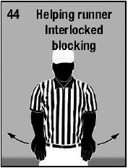
No one on the runner’s team is allowed to pull, carry or lift a runner forward to help the runner gain yardage. The rule also says you can’t push the runner, but by philosophy, we don not penalize merely pushing the runner.

PENALTY for Section 1 is Helping the Runner - 5 yard Penalty (Signal Follows)

(Referee, with palms facing forward, mimics a push/lifting motion as shown)

Section 2 Illegal Use of Hands and Holding
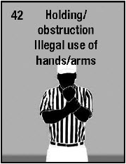
Article 1… Offensive players, besides the runner, shall not:
- Break any of the blocking rules in Rule 2-3-2 and 2-3-3, for example by contacting the defender in the head/neck area and maintaining contact, delivering a blow with the open hand, arm or forearm, or blocking by leading with closed fists.

PENALTY for Article 1a is Illegal Use of Hands - 10 yard Penalty (Signal is the same as for Holding)

- Grab onto a teammate and block together while holding a teammate.

PENALTY for Article 1b is Interlocked Blocking - 10 yard Penalty

- Use hands or arms to Grab and Restrict, Hook and Restrict, Take Down by throwing to the ground, Pull over while falling backwards, or Jerk and Restrict the defensive player.

PENALTY for Article 1c is Holding - 10 yard Penalty (Signal below)

Article 2… Runners can’t grasp and hold on to a teammate

PENALTY for Article 2 is Illegal Use of Hands - 10 yard Penalty (Same as Holding)

Article 3… Defensive Players may not…
- Break any of the blocking rules in Rule 2-3-2 and 2-3-3, for example by contacting the opponent in the head/neck area and maintaining contact, delivering a blow with the open hand, arm or forearm, or blocking by leading with closed fists.

- Use hands as leverage to help a teammate push forward or gain height on a leap at the line of scrimmage (usually seen when trying to block a kick)

PENALTY for Article 3a and 3b is Illegal Use of Hands - 10 yard Penalty (Same as Holding)

- Use hands or arms to Pull and Shoot to allow a teammate to go through as gap, Grab and Restrict (usually to keep a blocker from getting to his blocking assignment), or Grab or Hook an Eligible Receiver prior to the pass being released.

PENALTY for Article 3c is Holding - 10 yard Penalty

- Contact an eligible receiver who is clearly running a pass route and is moving past or moving away from the defender.

PENALTY for Article 3d is Illegal Use of Hands - 10 yard Penalty (Same as Holding)

Section 3 Illegal Blocking

Article 1… Kick Catch Interference, Pass Interference, and Personal Fouls can all be illegal blocking, though all of these fouls carry 15 yard penalties
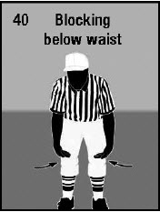
Article 2… Blocking below the waist is illegal unless it is by a player who starts the play on either the line of scrimmage and contact occurs while the ball is in the free blocking zone. Basically, this means for the block to be legal, it has to happen at the beginning of the play. The free blocking zone is pictured below:

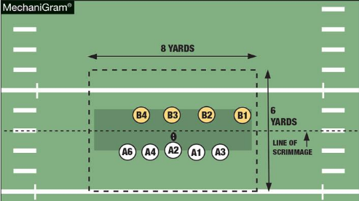

PENALTY for Article 2 is Illegal Block Below the Waist- 15 yard Penalty

Article 3… Once a receiver gives a Fair Catch signal (valid or invalid) the player cannot block an opponent until the kick ends. This means no blocking for the rest of the play.

PENALTY for Article 3 is Illegal Block - 15 yard Penalty (same signal is Illegal Block in the Back)
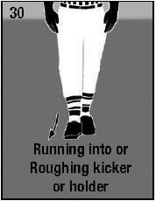
Article 4… On a Free Kick, the kicker or holder cannot be blocked until he has advanced at least 5 yards beyond the free kick line, or the ball touched another player or the ground

PENALTY for Article 4 is Illegal Block on the Kicker - 15 yard Penalty

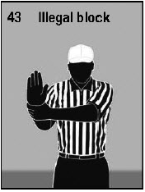
Article 5… Blocking in the Back is legal if it is in the free blocking zone and it is by an offensive lineman against a defensive player who started the play in the zone. It is also legal if it is attempt to get to a runner, or to legally recover or catch a loose ball. It is also legal to block a runner in the back while tackling.

PENALTY for Article 5 is Illegal Block in the Back - 10 yard Penalty

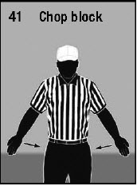
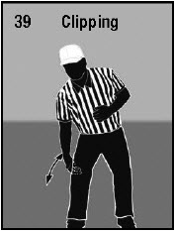
Article 6… No Chop Blocks and no Clipping is allowed, anywhere on the field

PENALTY for Article 6 is Chop Block or Clipping - 15 yard Penalty
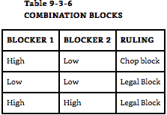

Article 7… On a Free Kick no one on the kicking team can block unless:
- The legal kick has gone 10 yards, or
- The kicking team is eligible to recover (because the receiving team touched the kick), or
- The receiving team starting blocking first

PENALTY for Article 7 is Illegal Block - 10 yard Penalty (same signal as Illegal Block in the Back)

Section 4 Illegal Personal Contact
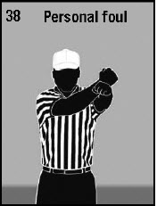
Most of the Major Contact Fouls are listed below. Unless otherwise noted, all carry a 15 yard penalty and are personal fouls.

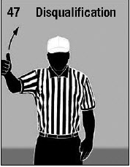

Article 1… Fighting; Automatic Disqualification

Article 2… Intentionally Contacting an Official; Automatic Disqualification

Article 3… and a long list of more personal fouls:
- Swinging the foot shin or knee into an opponent
- Hitting an opponent with force who is obviously out of the play or after the ball is clearly dead
- Piling on a player who is on the ground
- Hurdling
- Climbing onto the shoulders of a teammate or opponent to get higher and gain an advantage
- Throwing a helmet to trip an opponent
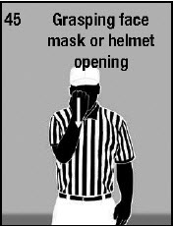
- Unnecessary or excessive contact, including against a defenseless opponent

- Grasping and turning or twisting a helmet opening, facemask, or mouthguard. IF is it only a grasp and not a twist or turn, the penalty is only 5 yards. Otherwise, it is 15.

- Committing Illegal Helmet Contact (Targeting) (See Rule 2 on Butt Blocking, Spearing, and Face Tackling)
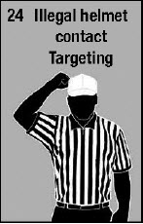
  - NOTE: If the official judges the helmet contact to be flagrant, then the player is disqualified. Flagrant acts include:

    - Targeting an opponent already on the ground
    - Targeting an opponent being held up by other players, or
    - Targeting a defenseless player

- Punching an opponent or striking with the forearm or elbow, or kicking or kneeing an opponent; Automatic Disqualification
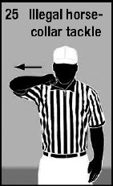
- Committing a Horsecollar Tackle by grabbing the inside back or side collar or the shoulder pads or jersey or nameplate area of the jersey of a runner and then pulling the opponent backward or sideways to the ground. It is still a foul even if the ball comes out or the runner steps out of bounds before hitting the ground. It is ALWAYS a live ball foul.

- Initiating contact against a helmetless opponent
- Targeting, which is initiating forceful contact to the head or neck area (see Rule 2-20-2)
- Committing a Blindside Block against an opponent without using open hands.
- Tripping

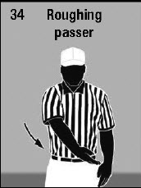
Article 4… Roughing the Passer, charging into the passer after is clear the ball has been thrown. Also, any personal foul against the passer from the previous article (9-4-3) becomes roughing the passer. This is important because Roughing the passer carries an Automatic First Down and has special enforcement. In Connecticut, it is also roughing the passer to forcefully contact the passer at the knee area or below (when the passer is in a passing posture), as well as punishing the passer when taking the passer to the ground, even if contact was not late.

Summary for Roughing the Passer:
High: Forcible Contact Head/Neck Area | Timing doesn’t matter | Always Roughing, even if not Targeting
Low: Forcible contact knee area or below | Timing doesn’t matter | Roughing only if in a passing posture, not on the run.
Late | After the ball is clearly away | Punishing, Avoidable contact after the pass is released
No Foul |  | Contact not punishing or forcible, even if High, Low, or Late

Article 5… Running into or Roughing the Kicker or Holder. Running into the kicker or holder carries a 5 yard penalty and is contact to the kicker or holder that doesn’t rise to the level of Roughing. It is not a foul if:
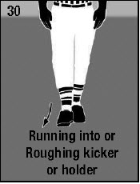
- Contact is unavoidable because it isn’t clear that the ball will be kicked (bad snap and scramble or kicker is running wide as if no kick is coming).
- Someone on the defense gets a piece of the ball near the kicker and the contact is avoidable
- The kicker moves unexpectedly and the contact is slight
- The defender is blocked into the kicker or holder

(Roughing is an Automatic First Down)
Summary for Roughing the Kicker (Late or just as the ball is kicked, timing doesn’t matter):
High: Forcible Contact Head/Neck Area | Timing doesn’t matter | Always Roughing, even if not Targeting
Low: Forcible contact to the plant leg | Timing doesn’t matter | Always Roughing
Forcible contact to the body of the kicker | Timing doesn’t matter | Always Roughing
Sliding under the kickers, plant leg, so the kicker has nowhere to land | Timing doesn’t matter | Always Roughing
Contact to the Kicking leg | Timing doesn’t matter | Running into if it displaces the kicker, can elevate to roughing if forceful enough

Article 6… Roughing the Snapper. Charging directly into the snapper when the kicking team is in a scrimmage kick (field goal or punt) formation. Automatic First Down

Article 7… Slapping the Head of a blocker by the defensive team

Article 8… Unintentional contact with an official on the sideline in the restricted area. There is special enforcement here. The first offense is a 15 yard penalty, charged as a dead ball foul. The second offense is the 15 yards plus the head coach is disqualified even if it wasn’t the head coach you ran into.

-------------------------------------------------------------------------------------------------------------------------------
Again, all of these fouls carry a 15 yard penalty, except the 5 yard facemask, and only Roughing fouls carry an Automatic First Down. All of these fouls can be ruled flagrant and result in disqualification as well as the 15 yard penalty.

Section 5 Noncontact Unsportsmanlike Conduct by Players

Article 1… Unsportsmanlike conduct
- Baiting or Taunting – words or gestures that embarrass, demean, or ridicule
- Profanity – vulgar language or gestures
- Excessive celebration – especially acts that unnecessarily draw attention to the player
- Kicking the ball in a non-kicking situation
- Hiding or otherwise leaving the field between downs to “gain an advantage”.
- Refusing to do what a game official asks the player to do
- Drinking alcohol or using any form of tobacco, at any time from arriving to the game site and until the participant has left the game site at the end of the game.

Article 2… Spiking or throwing the ball into the stands, etc after the ball is dead
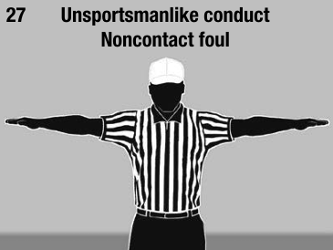
- Intentionally kicking the ball
- Spiking the ball into the ground
- Throwing the ball high into the air or out of play
- Intentionally not returning the ball to an official or to the ground after the play.

PENALTY for articles 1 and 2 is Unsportsmanlike Conduct, 15 yard penalty and counts towards disqualification. A player committing a second unsportsmanlike conduct foul is disqualified.

Section 6 Illegal Participation

Article 1… No player on the offense (Team A or K) may go out of bounds and return, even if by accident during any down, unless the player is blocked out of bounds. If there is a change of possession, the player may go out of bounds accidentally and return without a foul. When a player is blocked out of bounds, they must return at the first opportunity.

Article 2… Intentionally going out of bounds If any player intentionally go out of bounds, it is a foul if they:
- Return to the field
- Intentionally touch the ball
- Influence the play, or
- Otherwise participate

Article 3… Influencing the play from the bench. No one who is not a player currently in the game can tackle, block, or influence the play at all, nor touch the ball while it is live.

Article 4… Other Illegal Participation
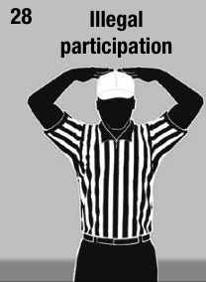
- Anyone who is part of the team (a player, coaches, or trainer, for example) enters the field and participate in a play
- An injured player must sit out 1 down or it is a foul
- 12 or more players participating during a down
- Using a hide out play or otherwise using substitution to fool the opponent into failing to cover an opponent who is near the sideline
- Any player lying on the ground to hide before the kick or the snap
- Any player coming back into the game after he has been disqualified
- A player participating after losing his helmet for any reason during play, beyond the immediate action when the helmet came off

PENALTY: 15 yards

Section 7 Illegal Kicking and Batting

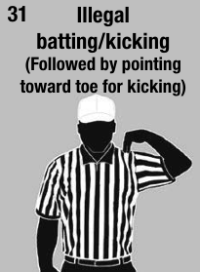
Article 1… No player shall intentionally kick the ball other than as a legal kick
Article 2… No player shall bat a loose ball unless it is a pass or an airborne fumble, or a kick he is attempted to block in the expanded neutral zone, or if he is batting it backwards to keep the punt from going into the end zone
Article 3… Passes may be batted in any direction by eligible receivers except for backward passes, which may not be batted forward by the passing team
Article 4… A ball possessed by a teammate may not be batted forward

PENALTY: Illegal Kicking or Batting, 10 yard penalty

Section 8 Noncontact Unsportsmanlike Fouls by Nonplayers

Article 1… This rule applies to coaches, bench players, trainers or anyone else officially part of the team. The rule is in effect whenever the officials have authority for the game. Examples include:
- Profanity, insulting or vulgar language or gestures
- Attempting to change an official’s call by pressuring the official or trying to otherwise influence the call
- Disrespectfully addressing the game official
- Overly objecting to a game official’s decision
- Using illegal communication equipment, such as video or radio. Electronic signs on the sideline are now allowed
- Holding a conference when not authorized to do so
- Failing to be on the field at the start of either half or by the time the 3 minute warm up period begins at halftime, or failing to follow the coin toss rules
- A coach is guilty of unsportsmanlike conduct if his players wear illegal equipment after confirming the players are legally equipped
- Being on the field when not a player
- Using alcohol or tobacco anytime starting from arriving at the game site until after leaving the game site at the end of the game
- Being outside the official team box
- Any bench player (substitute) going onto the field or leaving the team box during a fight.

PENALTY is Unsportsmanlike Conduct, 15 yard penalty and counts towards disqualification. A player committing a second unsportsmanlike conduct foul is disqualified.

Article 2… No one beyond those needed for a time out or dealing with an injured player may enter the field without permission of an official. During any timeout at the sideline, (outside the numbers) coaches, subs, water bearers, and trainers may all enter the field with their team, but if the charged time out is in the middle of the field, between the hashes, only one coach can go out.

PENALTY is only 5 yards and the false start signal is used, unless it is unsportsmanlike or repeated, in which case it is a 15 yard penalty.

Article 3… Sideline warnings: If any coach is in the restricted area during play, without contacting a game official, it is a sideline infraction. The first foul is penalized with only a warning (signal 15 below). The second time is a 5 yard penalty, and the third and any after that are 15 yards penalties.
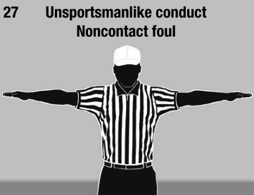
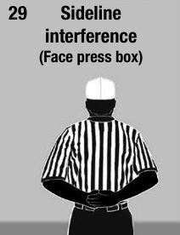
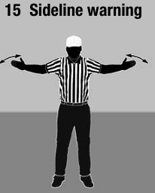

Section 9 Unfair Acts

Articles 1 -5: No team shall make a travesty of the game by doing any of the following, or anything else not specifically covered by the rules: committing repeated half the distance fouls, hiding the ball under a jersey, or using an obviously illegal kicking tee

