ECFO New Candidate Spring Class Rule Guide 2025, Rules 1 and 2
Adapted By- Michael Bilica

This is an introductory rulebook. Please use this rulebook as a guide to the official rule book. Consider it an easier to read translation. It is based on my attempt to rewrite the rulebook in my own words so that I can better remember it (This is a good practice by the way). However, if there are any differences between this guide and the rule book, the rule book will be the ultimate authority.

First of all, Rules are listed like this when talking about them:

Rule – Section – Article SubArticle, with the hyphens.

So, if we are talking about Rule 2, Section 9, Article 4, Sub Article b, we could write 2-9-4b
Table of Contents
Rule 1 The Game, Field, Players, and Equipment 2
Section 1 The Game 3
Section 2 The Field and Markings 4
Field Diagram 4
Section 3 Game Equipment 6
Section 4 Player Designations 7
Section 5 Player Equipment 7
Section 6 Coaches Field Equipment 8
Section 7 State Association Adoptions 8
Rule 2 Definitions of Playing Terms 8
Section 1 Status of Ball – Dead, Live, Loose 9
Section 2 Batting 9
Section 3 Blocking 9
Section 4 Catch 11
Section 5 Clipping 11
Section 6 Conferences 11
Section 7 Down – Loss of Down 12
Section 8 Encroachment 12
Section 9 Fair Catch 12
Section 10 Field Areas 13
Section 11 Fighting 13
Section 12 First Touching 13
Section 13 Force 14
Section 14 Formations 14
Section 15 Forward Progress 15
Section 16 Fouls and Penalties 15
Section 17 Free Blocking Zone – Legal Blocking Below the Waist and Block in the Back 16
Section 18 Fumble 17
Section 19 Handing 17
Section 20 Helmet Contact – Illegal 18
Section 21 Huddle 18
Section 22 Hurdling 18
Section 23 Interception 18
Section 24 Kicks 18
Section 25 Line of Scrimmage 19
Section 26 Lines 20
Section 27 Muff 20
Section 28 Neutral Zone 21
Section 29 Out of Bounds 21
Section 30 Participation 21
Section 31 Passing 21
Section 32 Player Designations 22
Section 33 Plays – For Penalty Enforcement 23
Section 34 Possession 24
Section 35 Ready for Play 24
Section 36 Recovery 24
Section 37 Rule 24
Section 38 Scrimmage 24
Section 39 Shift 24
Section 40 Snap 24
Section 41 Spots 24
Section 42 Tackling 26
Section 43 Team Designations 26
Section 44 Touching 26
Section 45 Tripping 26

Rule 1 The Game, Field, Players, and Equipment

High School football is a game designed for high school athletes. It is similar to the game you see on television on Saturday or Sunday, but there are some key differences. The main idea is the same. Players must wear helmets, shoulder pads, jerseys, pants, and cleats properly. There are rules regarding how they must wear their pads. The field looks familiar, but high school field markings are a little different, and Field Goal posts are wider. Teams run plays, and try to score touchdowns by running or passing. The kicking game and special teams are very important, as is field position. Understanding the game from a strategy perspective is just as important as knowing the rules.

Section 1 The Game

Article 1,2,and 3…
The object of the game is to score the most points by scoring touchdowns, field goals, and/or safeties. The game is played on a 100 yard field plus End Zones.

Teams start every possession with 4 downs, usually with 10 yards to go. Penalties can affect these distances, and are marked off between plays if they are enforced.

Teams play with 11 players.

Article 4,5,6,7, 8, 9,10, and 11…
The officials are responsible for all aspects of the game from the time they arrive on the field until the referee has completed any paperwork required after the game.

There is no Instant Replay in high school football, except in the state finals here in Connecticut.

The referee has broad authority to forfeit a game if appropriate, and protests are not recognized.

Section 2 The Field and Markings

Field Diagram
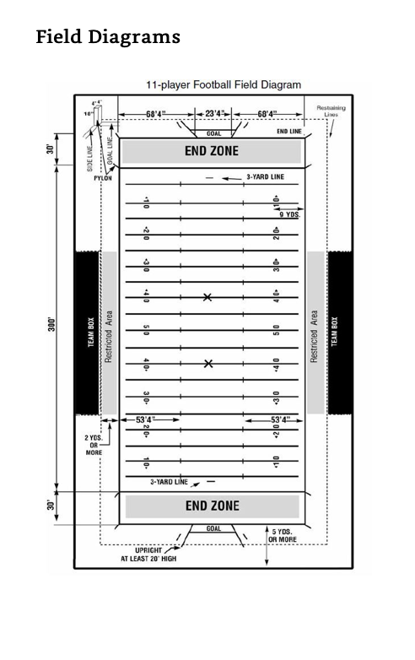
Article 1,2, and 3…
Grass fields should have a crown to help with runoff. Many fields will not have all of the markings shown above.
If there are no numbers on the field, marks (called 9-yard marks) should be placed where the top of the numbers would be.
There should be:
- Hash marks (also called inbounds marks).
- a mark at the 3 yard line, near each endzone, marking where the extra point (or Try) will be snapped from after a touchdown.
- Goal lines, Sidelines, and End lines
- Yard lines, at least every five yards
- Lines marking the Team area, keeping them between the 25 yard lines and 2 yards back from the field, unless the state lets them move it wider
- A Restraining line 2 yards off of the field, all the way around

Articles 4 and 5…
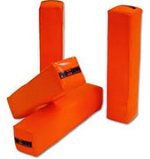
Four Pylons, which are orange, must be placed at the goal line and end line, touching the sideline so that they are completely out of bounds, but in the end zone. They line up with the lines if placed correctly and box in the end zone. Two more are placed where the hash marks would be if they continued past the end zone, and they are completely out of bounds behind the end line.

The Field goal posts (or Goal) are upright posts are will be fixed in place or can be on wheels and anchored. The area between the uprights, where field goals are scored, continues straight up forever. But a field goal attempt the passes directly over an upright is no good. It must pass between the uprights.

If the field is a college field, the uprights will be more narrow, but the game may still be played using college uprights.

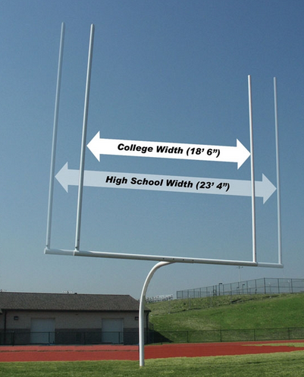
There must be a pad on the goal support to prevent players from banging into the metal part of the post.



Section 3 Game Equipment

Game equipment includes the ball, the tee, the chain and down marker, and the clock.

Article 1…
The ball must be shaped like a football. It must be inflated to 13psi and have particular size (see below) and be tan/brown in color.
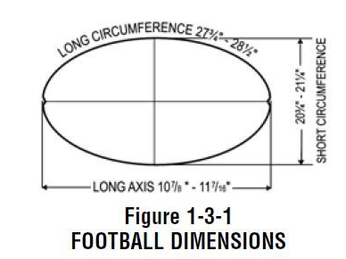
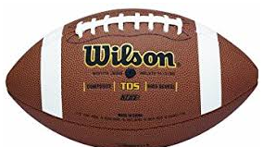
It has to have a white stripe as shown

The ball can’t have any advertising on it, except for logos/names from the manufacturer, school, conference, and state.

The ball must have one of the two following logos


Articles 2 and 3…
Before the game, the referee will check that all of the balls the team wants to use in the game are legal. Teams may only select a new referee-approved ball to kick off or each time they get a first down.

The offense cannot change the ball for the punter on 4th down, and they cannot change the ball for the extra point Try. If the defense or kick return team scores, however, they may bring in their own ball for the extra point Try. They don’t have to use the other team’s ball.
If the field is wet, the teams can switch out the balls more often. If a game official allows it, teams can also change balls after an incomplete pass or a ball goes well out of bounds.

If either team has no legal ball, it may use the other team’s ball. Technically, either team can use all approved balls.

Article 4…
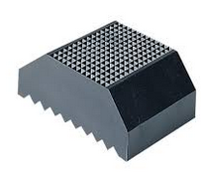
A high school kicking tee must be safe and can lift the ball at most 2 inches off the ground. There are many kinds of tees available. Field Goal tees are different than the kick off tee.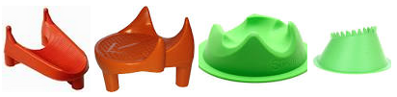

Article 5…
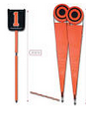
The chain is called the line-to-gain indicator in the rule book. The box (with the numbers 1,2,3,4) is called the down indicator. The line judge and head linesman should inspect the chain to make sure it measures 10 yards, and that the down indicator clearly shows all 4 downs. Also, the posts must have flat ends with caps on them for safety. During the game, they should be kept 2 yards back from the field at all times, or even with the front of the team area.

Article 6…
Game clocks on the scoreboard are official if the timer (clock operator) is a qualified official. If no qualified official is available or the clock malfunctions, the crew will keep the time on the field. The Back Judge always operates the play clock using a dedicated timer that he wears.

Article 7… Other equipment can be approved by the state, including Instant Replay in playoff games

Section 4 Player Designations

Articles 1,2, and 3…
Teams shall have up to 4 captains. Captains are allowed to make penalty decisions (But, officials should not ask if the choice is obvious, and the head coach should always be part of the decision). Teams can’t take a time out until after they the penalty choice is made.

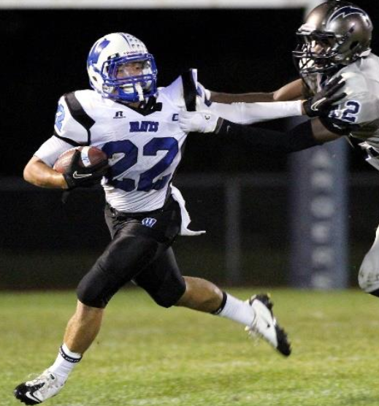
All players must be numbered 0-99. No number ‘00’. All 5 of the interior linemen on offense must have numbers 50-79. The other players on offense can be any available number. Players on defense can have any number. No two players shall have the same number while participating on the same play. Players may change jersey numbers during the game.

Section 5 Player Equipment

This rule covers virtually everything that a player may wear and may not wear. The list is extensive.

Article 1…
Required equipment includes Helmet with Facemask and Mouthguard; Jersey; Shoulderpads Hip pads, Tailbone pad; Pants with kneepads that cover the knees; and Shoes with or without cleats. Mouthpieces with unnecessary or dangerous add-ons are illegal.

Article 2 and 3…
Optional equipment includes other pads like forearm pads, knee braces, play cards (only allowed on the wrist or arm), Eyeshields (which must be clear), arm sleeves and gloves. No cameras or recording devices may be worn by players. Digital signs and pictures may be held up on the sideline to send in plays to the team on the field.

Article 4…
Before the game the coach must verify that all players are legally and properly equipped.

Article 5 and 6…
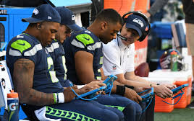
Players not meeting the equipment rules may not participate. If it can be fixed quickly (like a chinstrap) officials can stop the clock for repair. If a player is wearing illegal equipment or not wearing mandatory equipment, the player must leave for at least one play and can’t come back until it is legal.

Section 6 Coaches Field Equipment

Articles 1 and 2…
Pretty much any digital or video devices, such as iPads, phones, radios, and cameras may be used by coaches at any time on the sideline. They can only use them with players when they are off the field or during a Time out being held at the sideline (Outside the 9 Yard Marks Conference). These devices may not be brought out to a time out conference in the middle of the field and may NEVER be used to show an official video of a play.

Section 7 State Association Adoptions

States may make rules of their own. Here are some of the rules Connecticut uses:
- A running clock when one team is winning by 35 points in the 2nd half
- Overtime for Tied games as printed in the Rulebook
- 5 man crews unless the home team chooses 6 or 7 man crews
- 7 man crews in the Finals
- Use of a particular, sponsored, ball for the playoffs
- 10 minute quarters for Subvarsity games

Rule 2 Definitions of Playing Terms

This is by far the most important rule in the rulebook. In this rule, every football term is defined.

Section 1 Status of Ball – Dead, Live, Loose

Articles 1 and 2…
A ball is dead until it is put in play, at which point it becomes live. When the down ends, the ball is dead again. The only ways a dead ball becomes live is with a snap or free kick

Article 3…
A loose ball is a live ball that is a pass, fumble, or kick. A long snap is also a loose ball, until the quarterback catches it.

The loose ball takes on the name of what made it loose. So, if the ball was passed, the loose ball is called a pass. If a pass, kick, or fumble is still airborne, after being released, it is “in flight”. Loose balls that are in flight may be caught, as long as touching doesn’t make the ball dead.

Once a loose ball in flight hits the ground, it is called a “grounded” loose ball. Some loose balls become dead when they hit the ground, others can be recovered.

Section 2 Batting

Batting is an intentional slap or strike of the ball. You cannot accidentally bat a ball. You have to mean it.

Section 3 Blocking
Blocking is essential to football and it describes pretty much all contact between players except for attempts to tackle the ball carrier.

Article 1…
Blocking is contacting an opponent to get in his way, or push him away.

Article 2…
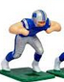
There are two kinds of blocking
- The old fashioned, hands on towards your chest,
closed hands, elbows out block
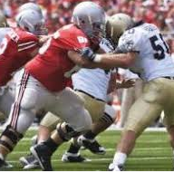
- The more common hands extended block, called open hands.
In this style of blocking, the hands are extended out, inside
the frame of both the blocker and the opponent, and the hands are open.

Article 3…
The blocker can’t lock arms with a teammate or swing the arms or elbows

Article 4…
A ball carrier can “stiff arm” an opponent and can push off to avoid being tackled. If there is a fumble, anyone can push or pull players in order to recover the ball. But they can’t hold someone or illegally block someone to help a teammate recover a fumble. Kicking team players may push to ward off an opponent when covering a kick.

Article 5…
Defenders can push or pull to get to a fumble or the ball carrier.

Article 6…
Defensive players cannot clothesline or head slap opponents.

Article 7…
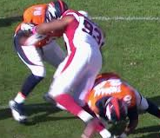
Blocking below the waist is a block that starts below the waist of the opponent, except from the back (that would be clipping, see below). It is not a block below the waist if the opponent has jumped off of the ground and isn’t touching the ground when blocked.

Article 8…
A Chop block is a block by two teammates, where one is or below the waist and the other is above the waist.

Article 9…
Interlocked blocking happens when teammates link arms and grab each other in an attempt to block
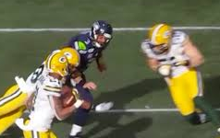
Article 10…
A Blindside block is a block that the opponent doesn’t see coming.

Section 4 Catch

Probably the most controversial rule in all of football these days, a catch is actually hard to define. Review video clips we share in class and it will help you.

Article 1…
A catch is only a catch after it is caught and the player lands inbounds with any part of the body. If a player grabs a loose ball but fails to maintain control after hitting the ground, it is not a catch. If a player grabs a loose ball and makes any kind of move after grabbing the ball, he has caught it. But remember no cheap fumbles. If it comes out very quickly when a receiver is hit just as he catches it, it is incomplete if it hits the ground. When in doubt, it is incomplete.

Article 2…
If touching the ball makes the ball dead immediately, it cannot be a caught. For example, if a player is standing on the sideline, the pass is incomplete and dead as soon as the player touches it.

Article 3…
When opposing players each catch or recover a loose ball at the same time, it is a simultaneous catch or simultaneous recovery.

Section 5 Clipping

Article 1…
Clipping is a block from behind and below the waist

Article 2…
Blocking in the back is a block from behind and at or above the waist., between the shoulders. Only the INITIAL CONTACT matters. If you don’t see the block from start to finish, it isn’t a block in the back. If the defender turns his back at the last second, it isn’t a block in the back.

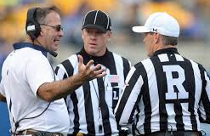
Section 6 Conferences

Article 1…
A Coach-Referee conference is when the coach thinks the officials got a rule wrong and wants to review it, or when the referee needs to explain an unusual situation. It happens at the sideline in front of the Team area.

Article 2…
An Authorized conference is a meeting between a coach or multiple coaches and players. There are two types (Only one type can be used at a time):
- Outside the 9-Yard Mark Conference – Multiple coaches meet with players outside the 9-yard marks (the numbers)
- Between the 9-yard Mark Conference – Only 1 coach meets with up to 11 players between the numbers in the middle of the field at his team’s huddle.

Section 7 Down – Loss of Down

Article 1…
A down is a play that starts with a snap or a free kick (kickoff). It ends when the ball becomes dead.

Article 2…
Some penalties carry a Loss of down. This means the team cannot replay the down after the penalty. Most penalties do not have a loss of down, so for example, if a penalty is enforced after a foul on 2nd down, it will still be 2nd down again on the next play. If there is a loss of down penalty, the down will be the next down.

Section 8 Encroachment

Encroachment is a foul by a player who is in the neutral zone (across his line) before the snap or before the free kick on a kickoff. It does not apply to substitutes entering the field and it does not apply before the ball is ready for play.

Section 9 Fair Catch

Article 1…
A Fair Catch is when a receiving team player signals and catches a kick, with the signal meaning that the receiving team will not try to run, or advance. The ball is dead when it is Fair caught. When a player makes a fair catch, he may not be blocked or tackled by an opponent.

A fair catch is only possible between the kicker’s line on a kickoff and the receiver’s goal line, or between the neutral zone and the goal line on a scrimmage kick (punt or field goal attempt)

Article 2…
An Awarded Fair Catch only happens after enforcement of the penalty for Kick Catch Interference, which is foul described in Rule 6.

Article 3…
A Valid Fair Catch is accomplished by any receiving team player waving one arm only, above the head and from side to side.

Article 4…
An Invalid Fair Catch is a signal before the kick has been caught or recovered and:
a.) is not Valid, or
b.) is after a receiving team player has touched the kick, or
c.) is after the kick has touched the ground

Article 5…
An Illegal Fair Catch is any signal by the player who caught or recovered the kick, after the kick has been caught or recovered. The runner can’t signal a fair catch while he is returning the kick.

Section 10 Field Areas
(See Page 4)
Article 1…
The Field includes all live ball territory that is inbounds, including the End Zones

Article 2…
The Field of Play is the entire Field, except the End Zones

Article 3…
The Side zones are the part of the Field of Play, outside the hash marks. The hash marks, or Inbounds marks divide the Field of Play into 3 equal width parts.

Article 4…
The End Zones are 10 yards deep, and the Goal line is entirely in the End Zone. A team’s end zone is the one it is defending. Teams try to score in the opponent’s End Zone.

Section 11 Fighting

Fighting is combative actions that are not football-related, even with no contact. If a participant swings and misses, it is still fighting.

Section 12 First Touching

Article 1…
First Touching is any time the kicking team touches the ball before it is allowed to recover it. There can be multiple spots of First Touching on the same play, if the kicking team touches it more than once before they can legally catch or recover the ball. On a Free Kick, the kicking team may not touch the kick before it goes 10 yards or it is touched by a receiving team player

Article 2…
On a Scrimmage Kick (A punt or field goal), the kicking team commits First touching if they touch the kick anywhere downfield past the Expanded Neutral Zone before the receiving team touches it. The Expanded Neutral Zone is defined in 2-28-2.

Section 13 Force

Force in football only applies to a ball entering the end zone. For example, if the offense runs backwards and is tackled in their own end zone, it is a safety because the force is from the offense.

Article 1 and 2…
Force is due to some action by a player that causes the ball to move from the field of play into the end zone. Initial Force is assigned to the team who carried, fumbled, kicked, passed, or snapped the ball. A New Force is may be assigned because of a bat, illegal kick, or a muff (2-27). The team that provides the force is Responsible for the ball being in the end zone.

Article 3…
Batting or Muffing a pass, kick, or fumble that is still in flight it not a new force. An illegal kick is always a new force, whether the loose ball is in flight or grounded, if it goes into the end zone.

Article 4…
Force is NOT a factor when:
- A legal kick goes into the opponent’s end zone. No matter how it got there, as long as it is still a kick, it is a Touchback.
- When a player throws a Backward pass or Fumbles and the loose ball goes forward into the opponent’s end zone, it is a Touchback if no one recovers it and it goes out of bounds there or otherwise becomes dead in the end zone.

Section 14 Formations

There are 3 kinds of formations in football:

Article 1…
A Scrimmage formation is when the ball will be snapped and the offense must have no more than 4 players in the backfield and at least 5 linemen to be legal

Article 2…
A Scrimmage kick formation is a scrimmage formation where no player is under center at the snap, and:
- It is a Field goal formation where a holder has a knee on the ground 7 yards deep and a teammate is 3 yards or less away, in position to kick, or
- It is a Punt formation where a player is at least 10 yards deep, ready for a long snap.

Article 3…
A Free-Kick formation (A kickoff formation) is used only on a Free-Kick down, and is:
- With all Receiving team players somewhere inbounds and behind their line.
- With all Kicking team players less than 5 yards behind line until it is kicked, except the kicker, who can be further back, and the holder who can be in front of the line when holding the ball for the kicker. As the kicker is planting to kick the ball, he can legally cross the line.

Section 15 Forward Progress

Article 1…
Forward Progress is where the ball is when the runner is no longer able to advance, or, if it is fumbled, where the ball is when it goes out of bounds. Progress is measured at the forward tip of the ball.

Article 2…
When a receiver is airborne and is pushed back after grabbing it, the receiver gets forward progress where the defender first contacted him, so long as the receiver completes the catch.

Section 16 Fouls and Penalties

Article 1…
A Foul is an infraction of the rules. When a foul occurs, a Penalty may be enforced if it is accepted. All fouls have penalties associated with them in the rulebook

Article 2…
Types of Fouls:
- Dead Ball – This is a foul that occurs while the ball is dead. (Between plays)
- Double – One or more fouls are committed by each team, resulting in offsetting penalties
- Flagrant – a severe or extreme foul that risks serious injury and/or are extremely vulgar or abusive.
- Live Ball – A foul while the ball is live, during a down.
- Multiple – Two or more live ball fouls by the same team. Only one may be accepted.
- Nonplayer or Unsportsmanlike – A noncontact foul while the ball is dead or during a down, but does not influence the play. This includes things like taunting, high stepping, rude gestures, etc. (There are 2 exceptions: Illegal Participation is specifically excluded, and can’t be a nonplayer foul. Also, the only contact foul that can be a nonplayer foul is when a coach or other nonplayer contacts an official accidentally.)
- Player – any foul by a player in the game (that isn’t unsportsmanlike or nonplayer). In the rulebook, player fouls are simply called ‘fouls’.
- Post-scrimmage kick – A special foul by the receiving team on scrimmage kicks
      - The foul must be during a punt or missed field goal
      - The kick must have crossed the expanded neutral zone during the play
      - The foul must be beyond the expanded neutral zone
      - The foul must be before the end of the kick.
      - The ball will not be next put in play by the kicking team
- Simultaneous with the snap – these are fouls that only become fouls at the moment the ball is snapped or free kicked.

Article 3…
No foul causes a team to lose possession

Article 4…
No foul causes a live ball to become dead

Article 5…
A Penalty is an enforcement action against a team that has fouled

Article 6…
Some violations are not technically fouls. For example, First Touching is not a foul; there is no penalty attached to it.

Section 17 Free Blocking Zone – Legal Blocking Below the Waist and Legal Block in the Back

The Free Blocking Zone is designed to allow normal blocking by linemen near their initial positions, before any players have gotten up to enough speed to make things dangerous. Remember, Chop Blocks and Clipping are illegal anywhere on the field!
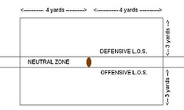
Article 1…
The Free Blocking Zone is centered on the ball at the snap, and is a rectangle, about 8 yards wide and about 6 yards deep. (4 yards laterally and 3 yards up and downfield from the ball)

Article 2…
Blocking Below the Waist is legal inside the zone when
- All players involved are on the line at the snap (offense or defense)
- The block occurs inside the zone.

Article 3…
Blocking in the Back is legal inside the zone when
- It is an offensive lineman against a defensive player in the zone at the snap.
- The block occurs inside the zone

Article 4…
The Free Blocking Zone disappears when the ball leaves the zone, and these two special blocks are no longer legal. Once the zone disappears, it is gone for the rest of the down. This is important when the quarterback takes a long snap.

Section 18 Fumble
A fumble is unintentionally losing control of a ball that is formerly in possession of a player.

Section 19 Handing
Article 1…
Handing the ball means the ball has been given from one player to another where the ball is always in contact with a player. If the handoff fails, and the ball becomes loose, it is a fumble.

Article 2…
Forward handing is when the player getting the ball is in front of the player handing it.

Article 3…
Backward handing is when the player getting the ball is even with or behind the player handing it.

Section 20 Helmet Contact – Illegal
Article 1…
There are 3 types of Illegal helmet contact, and also Targeting (Article 2 below):
- Butt Blocking is when a player uses the front of his helmet or facemask to block an opponent
- Face Tackling is like Butt Blocking, but when tackling a runner.
- Spearing is using the top of the helmet (the crown) to punish his opponent by ramming the opponent.

Article 2…
Targeting is taking aim and initiating contact at an opponent’s head or neck with any part of the body.

Section 21 Huddle
A Huddle is a group of 2 or more players, huddled together.

Section 22 Hurdling
Hurdling is trying to jump over an opponent feet first (or knees first) when the opponent is still on his feet (or one foot).

Section 23 Interception
An Interception is catching an opponent’s pass or fumble while it is still in flight. This is subject to the same Catch rule as for the pass receivers (2-4).

Section 24 Kicks
Article 1 and 2…
A Kick begins when it is kicked on purpose with any part of the leg from the knee down. The Kick ends when a player catches it, recovers it, or if the kick becomes dead.

Article 3…
When there is a Free Kick, the kicking team must all be behind their line, except the kicker and holder as described in 2-14-3. Free Kicks are used for any kickoff, including after a safety.

A team can try for a Field Goal using a Free Kick if they want to, but only after a Fair Catch.

Article 4…
Scrimmage kicks are when the play starts with a snap, and the kick has to be behind the line of scrimmage. It can be a place kick, punt, or drop kick.

Article 5…
For a Kickoff, the kicking team must use a place kick (off a tee), or a drop kick (like Rugby)

Article 6...
A Drop Kick is a rugby style kick, where the ball is dropped and kicked right as it touches the ground. You won’t see it in a game, but technically it can be used for free kicks and field goals. It can also be used after a safety.

Article 7…
A Place Kick is a kicking a ball off of a tee or the ground, and the ball is sitting still before the kick. A holder is allowed. This can be used for kickoffs, field goals, and after a safety. Teams do NOT have to punt after a safety, they can kick off a tee if they want to!

Article 8...
A Punt is a kick that can be used for punt plays and after a safety.

Article 9…
An Illegal Kick is any kick that is when the ball is kicked during play when it isn’t supposed to, such as when a rolling ball is kicked after a fumble. Illegally kicking the ball doesn’t turn it into a kick. It remains a Fumble, Snap, or whatever it was before the Illegal Kick.

Article 10…
A Pop-up Kick is only seen on onside kicks. It is when the kicker tries to drive the ball into the ground so it bounces up high in the air on the first bounce. It makes it look like a short pooch kick. …More on this in Rule 6.

Section 25 Line of Scrimmage
Article 1,2,and 3…
The Line of Scrimmage is an essential part of any play that starts with a snap. There are Two of them, one for the offense and one for the defense. Once the ball is set, each point of the ball defines the location of the lines of scrimmage. Any offensive lineman must be on the line of scrimmage (More on this later). Defensive players are on their line if they are within a yard of the line.

Section 26 Lines
(See Page 4)
Article 1…
The Sidelines and End lines are Out of Bounds.

Article 2…
The End Line is at the back of each end zone.

Article 3…
The Goal Line extends upwards forever. If a Runner is inbounds with the ball and reaches over the opponent’s Goal Line, it is a touchdown. The Goal line is extended out of bounds and the runner still scores, even if the ball is reached outside the pylon or hits the pylon, so long as the player didn’t go out of bounds first.

Article 4…
Hash Marks are short lines drawn at least every 5 yards to divide the field into thirds. They cross every 5th yard line (See diagram in Rule 1). Also known as Inbounds Marks.

Article 5…
The Line to Gain is the line that gives the offense a First Down. It is always 10 yards when the chains are set for a new first down, but penalties after the chains are set can make the distance shorter or longer. It is measured from the front of the ball. If there is less than 10 yards before a touchdown, then the Line to Gain on that First Down is the Goal Line.

Article 6 and 7…
Sidelines are the side limits, Yard lines mark the distance to each Goal line.

Article 8…
Restraining Lines tell the spectators and other people standing near the field exactly how far back they need to be and go all the way around the outside of the field. The only people allowed in front of the restraining line are officials and up to 3 coaches, and the coaches can only be there between plays.

Section 27 Muff
A Muff is when a player tries to grab a loose ball to take possession of it, but fails. A Muff can only happen if NO ONE is in possession.

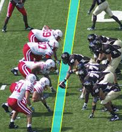
Section 28 Neutral Zone
Article 1…
The Neutral Zone is the area between the offensive and defensive lines of scrimmage, which is the length of a football. It is also the 10 yard area between the kicking line and receiving line on free kicks.

Article 2…
The Expanded Neutral Zone is when the Neutral Zone is expanded up to 2 yards for Punts and Field Goals, or to allow lineman to block a little bit downfield on a pass play. It is very important in Rules 6 and 7.

Section 29 Out of Bounds
Article 1…
Anyone is Out of Bounds when they are touching the anything out of bounds (including the sideline and end line. However, if the person is inbounds and is touching a player or game official who is out of bounds, they are still Inbounds. When a player is airborne, they continue to be Inbounds or Out of Bounds, depending where they were last.

Article 2…
A Ball that is still in possession is Out of Bounds when it touches anything out of bounds, except a game official or another player. This matters when the ball is being reached forward to get more progress as the player is going out of bounds.

Article 3…
However, a Loose Ball is Out of Bounds when it touches anything out of bounds. So, if the player fumbles, it is out of bounds when it touches another player who is already out.

Section 30 Participation
Anyone Participates by affecting a play in progress. It can be a player or nonplayer.

Section 31 Passing
Articles 1 through 6…
When a player throws the ball, it is a Pass. Any pass that is not Forward is a Backward Pass. Any pass ends when it caught or goes out of bounds. A Backward Pass continues even if it hits the ground (like a fumble). A Forward Pass ends when it hits the ground.

Section 32 Player Designations
Article 1...
A Player is a player who is actually in the game, 11 for each team.

Article 2…
Players on the offense are on Team A and can be abbreviated as A1 or A33, for example. The Defense is called Team B. The Kicking team and Receiving team on Kicks are K and R.

Article 3…
A Back is any player on offense who is not on the line, and is far enough in the backfield. “Far enough” means the back is behind the nearest lineman teammate’s waist. The only exception is the player taking the snap, who can be closer, usually the quarterback.

Article 4…
An offensive blocker is self explanatory. The player is trying to block the defense.

Article 5…
Captains can be at the Coin Toss, make Penalty Decisions, and choose where to spot the ball when the team has the option.

Article 6…
A Disqualified player cannot play in the game after being disqualified.

Article 7 and 8…
A Kicker and Holder continue to be protected as a kicker and holder until the kicker has regained his balance after kicking the ball. On a Free Kick this protection automatically extends until the kicker has advanced 5 yards.

Article 9…
To be legal, a Lineman must line up with shoulders mostly parallel to the line, facing forward, with head or foot even with or ahead of the Snapper’s waist at the snap. Linemen include Tight Ends and Wide Receivers if they are on the line.

Article 10…
Nonplayers are anyone associated with the team who is not a player. This includes coaches and bench players in the team area, and anyone else working for the team. Nonplayers cannot participate in play in any way.

Article 11…
A Passer is a player who throws a Legal Forward Pass. The passer is protected until the pass ends or the player moves to block, pursue, or otherwise get involved (participate)

Article 12…
A Replaced Player is a player who has been told by Substitute that the player is being subbed out. Replaced Players can also leave before the Substitute enters.

Article 13…
A Runner is a ball carrier or a player carrying out a fake, pretending to have the ball.

Article 14…
A Snapper is usually the center, and is the only lineman who can be partially over the line with his head or hand and arm. The Snapper’s shoulders must be mostly parallel with the line, facing forward. In a Punt or Field Goal formation with a long snap, the snapper is protected until balance is regained or the snapper participates in play.

Article 15…
Anyone on the bench who can replace a player on the field is a Substitute. Substitutes become Players when they take their position on the field or huddle, or notify a teammate or game official. Entering substitutes can cross the line of scrimmage on their way to their side of the ball; it is not Encroachment. But, they are still Substitutes until they get to their side of the line.

Article 16…
Defenseless Players include anyone who is particularly at risk of injury because they cannot protect themselves. This includes passers, kickers, holders, receivers focused on catching a ball, a runner who is already wrapped up, players well out of the play, and anyone getting a blindside block

Section 33 Plays – For Penalty Enforcement
This section is very important for knowing where to mark penalties from in various situations.

Article 1…
Loose Ball Plays are any plays where the ball becomes loose on a free kick or behind the neutral zone, including from a legal kick, forward pass, fumble, snap, and backward pass. Everything that happens between the snap and kick, pass, or fumble is part of the same loose ball play.

Article 2…
Everything else is a Running Play. This includes if a ball is fumbled or passed from beyond the neutral zone. There can be multiple Running Plays on the same down, and each time possession changes, a new Running Play begins. If there is more than one running play and a foul happens during one of them, the Penalty is enforced from the Related Run.

Section 34 Possession
Article 1…
Player possession is when a player on either team is holding or controlling a Live Ball.

Article 2 and 3...
One of the teams is always in Team Possession and this doesn’t change unless a player on the opposing team gains Player Possession. This is called a Change of Possession.

Section 35 Ready for Play
Ready for Play means that the offense or kicking team can snap or free kick the ball. There is a 40 or 25 second play clock.

Section 36 Recovery
Recovery is getting control of a loose ball that has already hit the ground. Recovery is only successful if the player meets the same standards as the Catch rule (2-4).

Section 37 Rule
Simply put, Rules state all of the regulations of Football, and can be found in the Rulebook. Read 2-37 in the rulebook when you can. (Lawyers were probably involved in writing it)

Section 38 Scrimmage
A Scrimmage down is any down starting with a snap. Free Kicks are the only plays that are not “from Scrimmage”

Section 39 Shift
A shift is when one or more offensive players moves to a new location and stops before the snap. The breaking of the huddle is a shift, as is any number of players moving into position, or changing position, as long as they come to a complete stop before the snap. (See Rule 7)

Section 40 Snap
Articles 1, 2 and 3...
A Legal Snap is when the Snapper moves the ball backward in a smooth, continuous and quick motion. For the Snap to be legal, it must touch a back before touching any offensive linemen. The center cannot snap it to a guard, for example. The Snap ends when it touches the ground or a player.

Section 41 Spots
Like 2-33, Plays for Penalty Enforcement, this section is very important.

Article 1…
The Basic Spot is a reference for penalties. It is usually the end of the run on a running play, or the previous spot on loose ball plays (See 10-4).

Article 2…
The Enforcement Spot is where the penalty is actually enforced from. It may be basic spot, or it could be another spot, depending on who committed the foul (See Rule 10).

Article 3…
The Dead Ball Spot is the spot of the front tip of the ball where the ball last became dead. When the ball is coming out of the team’s own end zone, however, the ball must be entirely out.

Article 4…
The Inbounds Spot is at the nearest hashmark when a play ends outside of the hashes. It is where the ball will be placed for the next play if this happens. However, if the ball becomes dead between the hashes, it will remain there.

Article 5…
The Out of Bounds Spot is where the ball went out of bounds.

Article 6…
The Post Scrimmage Kick Spot is the end of the kick on a Scrimmage Kick (Punt or Field Goal). It is used when the receiving team fouls as in Rule 2-16-2h.

Article 7…
The Previous Spot is where the ball started the last time it was snapped or free kicked.

Article 8…
The Spot of a Foul is where a foul occurred. If out of bounds, it is placed inbounds at the same yard line where is happened out of bounds.

Article 9…
The End of the Run Spot is:
- Where ended with no loss of possession, or
- Where the runner fumbled or passed the ball
- Another spot determined by something called the Momentum rule, where a loose ball is caught or recovered inside the player’s own 5 yard line and momentum takes the player into the endzone.(See 8-5)

Article 10…
The Succeeding Spot is where the ball would next be if there had been no foul on the play. If a team scores a touchdown and the opponent commits a foul during the play, there is an option for the penalty to be enforced on the next kickoff.

Section 42 Tackling
Tackling is how the defense tries to stop a runner.

Section 43 Team Designations
Article 1,2 and 3...
The Offense is in possession during a play and the Defense is the other team. Team A is the team that starts a play with possession and Team B is the other team, except on kick plays, when they are called K and R.

Article 4…
Even if the offense changes during the play because they lose possession, the teams keep their A and B label during the play until the down ends.

Section 44 Touching
Touching is any touching of the ball, whether the ball touches the player or the player touches the ball. Any touching by a game official who is inbounds is ignored. So, if a pass that is in flight hits an official who is inbounds, it can rebound off of the official and still be caught.

Section 45 Tripping
Tripping is when a player uses the lower leg to trip an opponent below the knee.

