ECFO New Candidate Class Rule Guide 2025, Rule 7
Adapted By- Michael Bilica

This is an introductory rulebook. Please use this rulebook as a guide to the official rule book. Consider it an easier to read translation. It is based on my attempt to rewrite the rulebook in my own words so that I can better remember it (This is a good practice by the way). However, if there are any differences between this guide and the rule book, the rule book will be the ultimate authority.

Table of Contents
Rule 7 Snapping, Handling, and Passing the Ball 1
Section 1 Before the Snap 1
Section 2 Formation/Position, Numbering and Action at the Snap 3
Section 3 Handing the Ball 5
Section 4 Fumble and Backward Pass 5
Section 5 Forward Pass Classification 6

Rule 7 Snapping, Handling, and Passing the Ball

Section 1 Before the Snap

Article 1… Only the Snapper may be over the ball, the snapper’s feet must be behind the Neutral Zone. Only a hand on the ball may be beyond the forward point of the ball.

Article 2… The Snapper may Adjust the ball before the snap by rotating it and standing it any any vertical angle. However, the Snapper may not rotate the ball end-for-end and may not turn it sideways.

Article 3… After the Ready for Play signal, the Snapper’s Restrictions are as follows:
- The snapper may not
- Remove BOTH hands from the ball, (The snapper can remove one, as long as one remains)
- Make a move that simulates the snap
- Fail to come set before the snap (there must be a pause after adjustment)
- Following adjustment, lifting or moving the ball, unless starting a legal snap

Article 4… If the Snap is illegal, The ball remains Dead.

Article 5 and 6… Once the ball is marked Ready for Play, no other player may be in the neutral zone, touch the ball or an opponent. Then, once the snapper places his hands on the ball, it is Encroachment if any other player enters the neutral zone, or if a defensive player makes contact with the ball before the snap or makes contact with the hand or arm of the snapper during the snap.

Article 7… A False Start is
- a shift or movement by a Team A player that simulates the start of the play
- any coordinated shift or movement by A that is clearly designed to caused Team B to jump/Encroach.
- A Team A lineman between the ends lifting a hand after having already placed it on the ground.
- Any Team A lineman moving hands or making any quick movement

Article 8… If Team A False Starts and that causes B to Encroach, then it is only a False Start, the Encroachment is ignored.

Article 9…If any Team B claps his hands, yells “hut hut”, or any other disconcerting act to interfere with Team A’s presnap moves or signals, it is a foul.

PENALTY for Article 1, 5, and 6 is Encroachment, Dead Ball - 5 yard Penalty (Signals Follow)
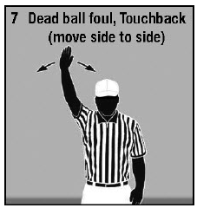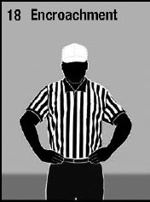
PENALTY for Article 2,3 is a Snap Infraction, and Article 7 is a False Start , Dead Ball – 5 yards
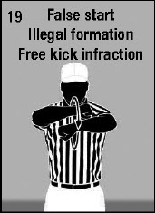
PENALTY for Article 9 is a Disconcerting Act, Dead Ball – 5 yards
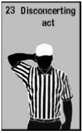

Section 2 Formation/Position, Numbering and Action at the Snap

Article 1… After the Ready for Play, Each Team A player must have been between the 9 yard marks (The Numbers) at some point before the Snap. This rule is designed to help prevent the “Hideout” play.

Article 2… Only the Snapper and Lineman on either side of the snapper may lock legs. Other Team A linemen must not cross legs with a teammate. Otherwise, Team A players can stand, croach, or kneel, so long as they are facing downfield.

Article 3… All Team A players must be either a Lineman or a Back. To be a back, a Team A player must not be in front of the waist of the nearest teammate who is on the line, unless the player is in position to receive the snap (the quarterback). (See Rule 2-32-3)

Article 4… A snap is legal if it immediately leaves the hand or hands of the snapper and touches a back or the ground before it touches a Team A lineman. This rule is designed to prevent the “Guard Around” play where the snapper holds the snap between his legs and the guard takes it. If a snap is illegal, the ball remains Dead.

Article 5… Numbering Requirements for Team A
- At the snap, there must at least 5 players on the line, and no more than 4 players in the backfield, only one back can be breaking the waist line of a lineman (the QB?)
- 5 of these linemen must have a number from 50 through 79
EXCEPTIONS:
- In a Field Goal formation on 1st, 2nd or 3rd down, the snapper can be any number, but Four other linemen must have a number from 50 though 79. If Team A is using this exception, the snapper cannot be an eligible receiver, and must be between the ends.

- In any Kicking formation on 4th down or during the Try, Team A linemen may have any number. Any of the 5 players using the exception must be lined up between the ends and are ineligible receivers.

Numbering Requirements for Team B, they can wear any number
- Players on the same team can’t play with the same number on the same down
- Team B players can line up anywhere behind the neutral zone and can move in any direction before the snap.

Article 6… All 11 players must be Set for one second before the snap, and following breaking of the Huddle or any Shift. Being Set means coming to an absolute stop without movement of the hands, feet, head, or body.

Article 7… One player may be In Motion at the snap, only after all 11 players are Set for one second, or else it would be a Shift. The player In Motion must be a back and this motion must be parallel to or away from the line at the snap. If the player goes in motion starting from the line, the player must first step back off of the line and set for one second, establishing as a back, before going In Motion, or must be In Motion 5 yards behind the line. A player In Motion is the only Team A player that is allowed to be moving at the snap.

Article 8… Planned loose ball plays behind or around the snapper are Illegal. This rule makes the “Fumblerooski” play illegal.

PENALTY for Articles 1,2, and 3 – Illegal Formation – 5 yards
PENALTY for Article 4 – Illegal Snap – Dead Ball – 5 yards
PENALTY for Article 5 – Illegal Numbering – 5 yards

PENALTY for Article 6 – Illegal Shift (2 hands) and Article 7 – Illegal Motion (1 hand) – 5 yards
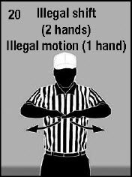
PENALTY for Article 8 – Planned Loose Ball Play – 5 yards

Section 3 Handing the Ball
Article 1… Any player can hand the ball backward anytime

Article 2… Only Team A players behind the neutral zone can hand the ball forward, and
- It can be to a lineman only if the lineman had turned to face his own end line and stepped back at least one yard behind the line before receiving the ball. This rule is designed to prevent the “Guard Around” play.
- It can be to any back or an End, so long as the End was not Snapper or right next to the Snapper

Article 3… After a change of possession, no one can hand the ball forward to a teammate.

PENALTY for Articles 2 and 3 – Illegal Handing – 5 yards and includes a LOSS OF DOWN
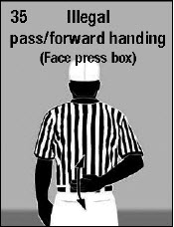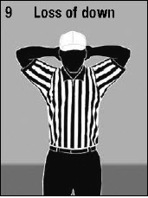

Section 4 Fumble and Backward Pass
Article 1… Any player in possession may make a backward pass or fumble anytime

Article 2… Any player can catch or recover a backward pass or fumble anytime and advance

Article 3… If any of the following happen to the team who fumbles or throws a backward pass, that team keeps the ball
- The backward pass or fumble goes out of bounds anywhere except in the end zone
- The backward pass or fumble becomes dead inbounds while loose
- The backward pass or fumble is jointly possessed by opponents, and is therefore dead

Article 4… Anytime a backward pass or fumble goes out of bounds in the end zone, the responsibility is put on the team that passed or fumbled it, and the result is either a Touchback or a Safety (See Rule 8-5)

RULE CHANGE: Fumbles that go forward out of bounds will be returned to the spot of the fumble to start the next play. The clock will be started on the referee’s signal. Fumbles that go backwards out of bounds will be places at the spot they went out of bounds for the next play. The clock in this case will start on the next snap.

Section 5 Forward Pass Classification

Article 1… A Legal Forward Pass is defined as a forward pass thrown by the offense by a player with both feet in or behind the neutral zone before a change of possession. Only one Forward Pass may be thrown each down. Forward passes are illegal on Free Kick Downs.

Article 2… An Illegal Forward Pass is a foul and is any one of the following:
- A forward pass after a change in possession
- A forward pass from beyond the neutral zone
- A second forward pass during the same down
- A forward pass thrown intentionally into an area with no eligible receiver
EXCEPTION: A passer, who was the first to possess the snap, who is outside the tackles (free blocking zone) can throw the ball away as long as it reaches at least the line of scrimmage, whether it lands in or out of bounds
- A forward pass thrown intentionally incomplete to save yardage or time
EXCEPTION: It is legal to spike the ball immediately to stop the clock, if the player does so immediately after controlling the snap, whether in Shotgun or under center.

Article 3… The spot of Enforcement for an Illegal Forward Pass penalty is the spot of the pass. If the other team Declines the penalty, the other team still has the choice to take the result of the play or leave the ball at the spot of the pass with the Down counting.

Article 4… A Complete Forward Pass is an Illegal or Legal Forward Pass that is Caught by a player of either team. The ball may be advanced, unless it is caught Simultaneously by opponents, in which case it is dead and belongs to the passing team.

Article 5… An Incomplete Forward Pass is an Illegal or Legal Forward Pass that becomes Dead when it touches the ground or anything out of bounds. It is also Incomplete if an airborne receiver touches out of bounds before the receiver is able to touch inbounds.
After a Legal Incomplete Pass, the ball is returned to the spot where the ball was snapped and the down counts. After an Illegal Incomplete Pass the down counts unless there was a change of possession before the pass.

Article 6… Pass Eligibility Rules
- Team A players who are Backs or Ends and have numbers 1-49 or 80-99 are Eligible
- If Team B touches a legal forward pass, all players become Eligible
- All Team B players are always Eligible
- Anyone Eligible at start of the down cannot lose Eligibility

Article 7… Pass Interference
Interference restrictions only apply
- Beyond the Neutral Zone
- during a Legal Forward Pass that crosses the Neutral Zone
- On a Legal Forward Pass untouched by B in or behind the Neutral Zone
- To ALL players until the pass is Touched or Incomplete

Article 8… Restrictions for Pass Interference BEGIN for the following players when:
- All Team A players at the Snap
- All Team B players when the pass is thrown

Article 9… Restrictions for Pass Interference END for the following players when:
- All eligible Team A players when the pass is touched by any player
- All Ineligible Team A players (The 5 linemen) when Team B touches the pass, further, these players can legally block and it isn’t pass interference.
- All Team B players when the pass is touched by any player
- All players when the pass is incomplete

Article 10… Forward Pass Interference is when any player beyond the neutral zone interferes with an eligible player’s ability to move toward, catch, or bat a Legal Forward Pass

Article 11… It is NOT Forward Pass Interference if:
- Eligible players are both going for the ball at the same time and contact is unavoidable
- A Team A lineman is blocking within the neutral zone immediately after the snap and the block does not continue beyond the neutral zone
- Contact by Team B is not anywhere near the direction of the pass
Article 12… Ineligible Players are Illegally Downfield when they are beyond the Expanded Neutral Zone anytime during the play before a Legal Forward Pass that crosses the Neutral Zone in Flight is thrown. Once Team B touches a pass in or behind the Neutral Zone, there is no more restriction. It is not a foul if a Team A lineman is blocking within the Neutral Zone immediately after the snap and the block does not continue beyond the Neutral Zone

Article 13… Illegal Touching is when an Ineligible Player bats, muffs, or catches a Legal Forward Pass before it has been touched by Team B.

PENALTY for Article 2a,b,c – Illegal Forward Pass – 5 yards, LOSS of DOWN for 2b,c
PENALTY for Article 2d,e – Intentional Grounding – 5 yards, LOSS of DOWN
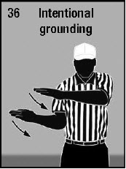
PENALTY for Article 10 – Pass Interference – 15 yards
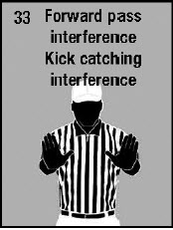
PENALTY for Article 12 – Ineligible Downfield – 5 yards
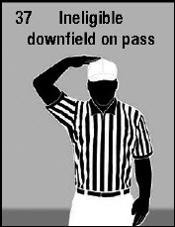
PENALTY for Article 13 – Illegal Touching – 5 yards, LOSS of DOWN
